Final Assessment-Alternative Assessment
Semester | 202520 | Division | CIS
Assessment title in Syllabus | Final_Project_Portfolio | Program | Bachelor of Information Technology/ Bachelor of Information Systems
Course Code | CDS 2413
Course Title | INTRODUCTION TO DATA SCIENCE
Course Instructor |  | CRN
Assessment | Project Deliverable 2 – Machine Learning Model Report | Submission Date | Week 13
Student Declaration:
Academic Integrity Statement
In accordance with the HCT Academic Integrity Policy
• Students are required to refrain from all forms of academic integrity breaches as defined and explained by HCT.
• A student found guilty of having committed acts of academic integrity breach(es) will be subject to the relevant sanctions as outlined by HCT.
إفادة النزاهة الأكاديمية
وفقًا لسياسة كليات التقنية العليا للنزاهة الأكاديمية
• على الطلبة الإلتزام بلوائح وقواعد النزاهة الأكاديمية، كما هو مبيّن وموضح في السياسات والإجراءات الخاصة بكليات التقنية العليا.
• في حالة ارتكاب الطالب أي شكل من أشكال الإخلال بالنزاهة الأكاديمية، سيتعرض الى العقوبات الموضحة في السياسات ذات الصلة.
This assignment is entirely my/our own work except where I have duly acknowledged other sources in the text and listed those sources at the end of the assignment. I have not previously submitted this work to the HCT, or any other entity. I understand that I may be orally examined on my submission.

Student HCT ID(s): | H00532714 | H00532943 | H00532797 | H00
Student Name(s): | Noorman Ghaith | Afra Saeed | Meera Mansoor
Student Signature
Chatbot (e.g. ChatGPT) statement
This submission allows you to use AI generated tools, but the prompt used must be stated and the response must be in red font. Include References to ChatGPT.

Instructions

CLO3: Machine Learning Model (25 Points)

Preprocessing(5 Points)

Data Collection (1 Point)
Python libraries are used to load the dataset, process the data, build machine learning models, and evaluate model performance.
The following Python libraries are used in this machine learning analysis:
- Pandas: to read and manage the dataset.
- NumPy: for numerical operations.
- Matplotlib: for visualization.
- Scikit-learn: for preprocessing, model building, splitting, scaling, and evaluation.
# Importing libraries
import numpy as np
import pandas as pd
import matplotlib.pyplot as plt

from sklearn.model_selection import train_test_split
from sklearn.impute import SimpleImputer
from sklearn.preprocessing import OneHotEncoder, StandardScaler, PolynomialFeatures
from sklearn.compose import ColumnTransformer

from sklearn.linear_model import LinearRegression, Ridge, Lasso, ElasticNet
from sklearn.metrics import mean_squared_error, r2_score

Dataset loading:
The dataset is loaded using Pandas from the CSV file.
dataset = pd.read_csv("train.csv")

Variable selection :
For the regression model, the independent variables are selected as:
- Loan Amount
- Debit to Income
- Employment Duration
- Home Ownership
- Total Current Balance
- Grade
The dependent variable for regression is:
- Interest Rate
# Independent variables
X = dataset[['Loan Amount',
'Debit to Income',
'Employment Duration',
'Home Ownership',
'Total Current Balance',
'Grade']]

# Dependent variable for regression
y = dataset['Interest Rate']

Justification:
These variables were selected because they represent financial behavior, employment status, ownership information, and credit grading, which may affect the loan interest rate.
Data Cleaning (1 Point)
The dataset may contain missing values. Missing numerical values are handled using SimpleImputer with the mean strategy.
Mean imputation replaces missing numerical values with the average value of the same column. This keeps the dataset complete and avoids losing records.
Missing values may affect model performance and must be handled before training.
# Handling missing values in numerical columns
numeric_columns = ['Loan Amount', 'Debit to Income','Total Current Balance']

imputer = SimpleImputer(strategy='mean')

X[numeric_columns] = imputer.fit_transform(X[numeric_columns])

Duplicate records can also be removed to improve data quality:
# Removing duplicate rows
dataset = dataset.drop_duplicates()

Treating the Categorical Variables (1 Point)
The dataset includes categorical variables that must be converted into numerical form before applying machine learning models.
The categorical variables used are:
- Employment Duration
- Grade
- Home Ownership
These variables contain text labels and cannot be processed directly by regression models.
One-Hot Encoding is applied to convert these categorical values into numerical binary variables.
# Encoding categorical variables

categorical_columns = ['Employment Duration', 'Grade','Home Ownership']

ct = ColumnTransformer(

transformers=[('encoder', OneHotEncoder(handle_unknown='ignore'), categorical_columns)],

remainder='passthrough'
)
X = ct.fit_transform(X)
One-Hot Encoding is suitable because it converts categorical values into binary columns without creating false numerical relationships between categories.
Splitting the Dataset (1 Point)
The dataset is split into training and testing sets.
- Training set: used to train the model.
- Testing set: used to evaluate how well the model performs on unseen data.
An 80/20 split is used:
- 80% training
- 20% testing

# Splitting dataset into training and testing sets
X_train, X_test, y_train, y_test = train_test_split(
X, y, test_size=0.2, random_state=42
)

This helps prevent overfitting because the model is evaluated on data it has not seen during training.

Feature Scaling (1 Point)
Feature scaling is applied using StandardScaler.
Feature scaling is important because the selected variables have different numerical ranges.
For example:
• Loan Amount may be very large
• Debit to Income may be relatively small
Without scaling, larger values may dominate the model.
StandardScaler standardizes all features to improve model fairness and model convergence.

# Feature scaling
sc = StandardScaler(with_mean=False)

X_train = sc.fit_transform(X_train)
X_test = sc.transform(X_test)
StandardScaler standardizes features so they have approximately:
- mean = 0
- standard deviation = 1

Regression Model (7 Points)

Building the Regression Model (6 Points)
The regression model is used to predict the Interest Rate based on selected financial and borrower-related features.
The following regression models are implemented and compared:
- Multiple Linear Regression
- Polynomial Regression (Degree 2)
- Ridge Regression
- Lasso Regression
- Elastic Net Regression
- Decision Tree Regression
- Random Forest Regression
These models are evaluated using Mean Squared Error (MSE) and R-Squared (R²) to determine the best-fit model.

1. Loading and Preprocessing the Data

The regression model uses the same dataset prepared in the preprocessing section.
The selected independent variables (X) are:
- Loan Amount
- Debit to Income
- Employment Duration
- Home Ownership
- Total Current Balance
- Grade
The dependent variable (y) is:
- Interest Rate
These variables were selected because they represent the borrower’s financial condition, employment information, ownership status, and credit grade, which may influence the loan interest rate.
Before building the regression models:
- Missing values were handled using mean imputation.
- Categorical variables were converted into numerical form using One-Hot Encoding.
- The dataset was prepared for training and testing.
This ensures the data is clean and suitable for regression analysis.

2. Detecting and Removing Outliers
Outliers are extreme values that can affect regression model performance and reduce prediction accuracy.
To identify and remove outliers, the Interquartile Range (IQR) method was used.
The IQR is calculated as:
IQR = Q3 - Q1
Where:
- Q1 = First quartile (25%)
- Q3 = Third quartile (75%)
The outlier boundaries are calculated as:
Lower boundary:
Q1 - 1.5 \times IQR
Upper boundary:
Q3 + 1.5 \times IQR
Any value outside these boundaries is identified as an outlier and removed from the dataset.
# Reload dataset for regression outlier handling
dataset = pd.read_csv("train.csv")

# Select independent variables and target variable
feature_cols = [
'Loan Amount',
'Debit to Income',
'Employment Duration',
'Home Ownership',
'Total Current Balance',
'Grade'
]

target_col = 'Interest Rate'

# Keep selected columns only
data_reg = dataset[feature_cols + [target_col]].copy()

# Remove rows where target variable is missing
data_reg = data_reg.dropna(subset=[target_col]).copy()

# Separate X and y
X_reg = data_reg[feature_cols].copy()
y_reg = data_reg[target_col].copy()

# Numeric columns for outlier detection
numeric_outlier_cols = [
'Loan Amount',
'Debit to Income',
'Total Current Balance'
]

# Calculate IQR
Q1 = X_reg[numeric_outlier_cols].quantile(0.25)
Q3 = X_reg[numeric_outlier_cols].quantile(0.75)
IQR = Q3 - Q1

# Detect outliers
outlier_condition = (
(X_reg[numeric_outlier_cols] < (Q1 - 1.5 * IQR)) |
(X_reg[numeric_outlier_cols] > (Q3 + 1.5 * IQR))
).any(axis=1)

# Remove outliers
X_clean = X_reg.loc[~outlier_condition].copy()
y_clean = y_reg.loc[~outlier_condition].copy()

# Show dataset size
print("Original dataset size:", X_reg.shape)
print("Cleaned dataset size:", X_clean.shape)

Output

Original dataset size: (67463, 6)
Cleaned dataset size: (61497, 6)

Explanation
The dataset originally contained 67,463 records.
After applying the IQR method, 5,966 records were removed as outliers.
This represents approximately 8.84% of the dataset.
Removing outliers improves data quality and helps regression models generate more stable and reliable predictions.

3. Encoding, Scaling, and Splitting the Data
After removing outliers, the cleaned dataset must be prepared for regression modeling.
The independent variables are:
- Loan Amount
- Debit to Income
- Employment Duration
- Home Ownership
- Total Current Balance
- Grade
The target variable is:
- Interest Rate
The categorical variables are converted into numerical format using One-Hot Encoding. In this dataset,Home Ownership is stored as a numirical column, so only Employee Duration and Grade are encoded.
Feature scaling is then applied using StandardScaler to standardize the data before training.
Finally, the dataset is split into:
- 80% Training Data
- 20% Testing Data
This allows the model to learn from training data and evaluate performance on unseen data.
# Encoding categorical variables
categorical_cols = [
'Employment Duration',
'Grade'
]

ct_reg = ColumnTransformer(
transformers=[
('encoder',
OneHotEncoder(handle_unknown='ignore'),
categorical_cols)
],
remainder='passthrough'
)

X_clean = ct_reg.fit_transform(X_clean)

# Feature scaling
sc_reg = StandardScaler(with_mean=False)

X_clean = sc_reg.fit_transform(X_clean)

# Train-test split
X_train, X_test, y_train, y_test = train_test_split(
X_clean,
y_clean,
test_size=0.2,
random_state=42
)

4. Applying Regression Models

Regression Models
Multiple regression models are applied to predict the target variable Interest Rate.
The following regression models were implemented:

1. Multiple Linear Regression
What is it?
Multiple Linear Regression is a statistical model used to predict a continuous target variable using multiple independent variables.
How does it work?
It builds a linear relationship between the input variables and the target by fitting the best straight-line equation.
How will it benefit us?
It helps identify how financial factors affect interest rates and provides simple interpretable predictions.
linear_model = LinearRegression()

linear_model.fit(X_train, y_train)
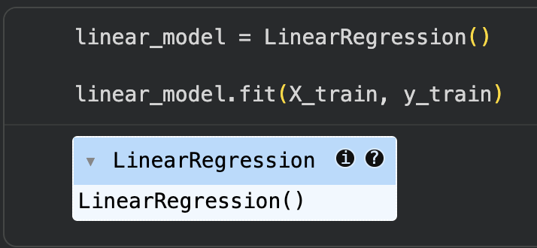

2. Polynomial Regression (Degree 2)
What is it?
Polynomial Regression is an extension of linear regression used to model non-linear relationships.
How does it work?
It transforms the independent variables into polynomial terms, allowing the model to fit curved relationships.
How will it benefit us?
It helps detect more complex relationships between borrower features and interest rates.
poly = PolynomialFeatures(degree=2)

X_poly = poly.fit_transform(X_train)

poly_model = LinearRegression()

poly_model.fit(X_poly, y_train)
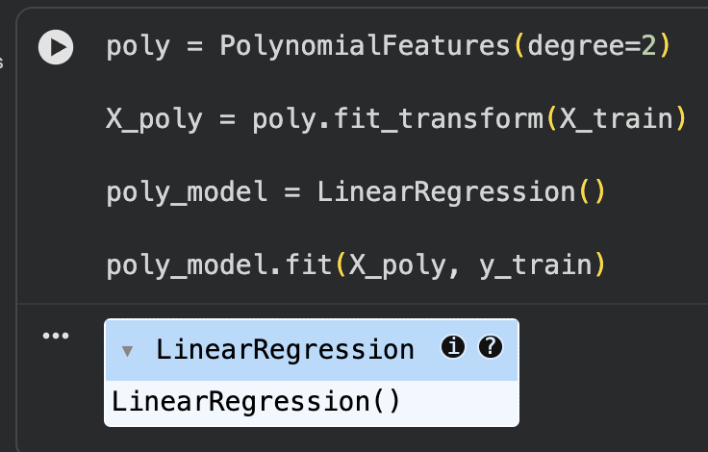

3. Ridge Regression
What is it?
Ridge Regression is a regularized version of linear regression.
How does it work?
It adds an L2 penalty to reduce the size of coefficients and prevent overfitting.
How will it benefit us?
It improves model stability and reduces prediction error.
ridge_model = Ridge()

ridge_model.fit(X_train, y_train)
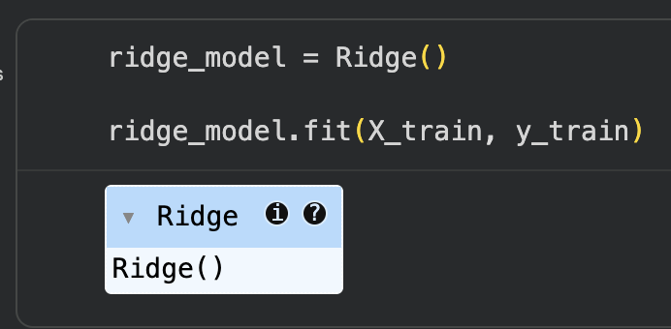

4. Lasso Regression
What is it?
Lasso Regression is a regularized regression model.
How does it work?
It uses an L1 penalty to shrink some coefficients to zero, performing feature selection.
How will it benefit us?
It simplifies the model by removing less important variables.
lasso_model = Lasso()

lasso_model.fit(X_train, y_train)
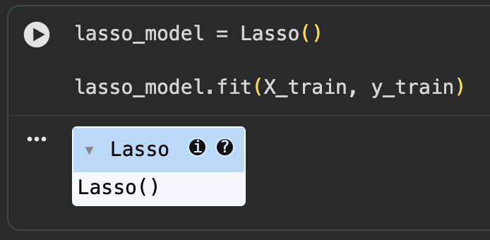

5. Elastic Net Regression
What is it?
Elastic Net combines Ridge and Lasso Regression.
How does it work?
It applies both L1 and L2 penalties for regularization and feature selection.
How will it benefit us?
It balances stability and simplicity in the regression model.
elastic_model = ElasticNet()

elastic_model.fit(X_train, y_train)

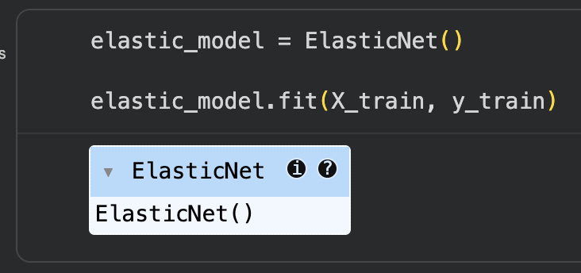

6. Decision Tree Regression
What is it?
Decision Tree Regression is a tree-based prediction model.
How does it work?
It splits the dataset into branches based on decision rules until predictions are made.
How will it benefit us?
It helps capture complex decision patterns in financial data.
from sklearn.tree import DecisionTreeRegressor
decision_tree_reg = DecisionTreeRegressor(
random_state=42
)
decision_tree_reg.fit(
X_train,
y_train
)
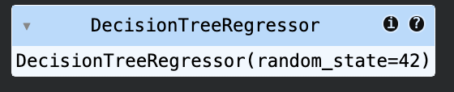

7. Random Forest Regression
What is it?
Random Forest Regression is an ensemble learning model made of multiple decision trees.
How does it work?
It combines the predictions from many trees to improve accuracy.
How will it benefit us?
It reduces overfitting and improves prediction reliability.
from sklearn.ensemble import RandomForestRegressor
random_forest_reg = RandomForestRegressor(
n_estimators=100,
random_state=42
)
random_forest_reg.fit(
X_train,
y_train
)
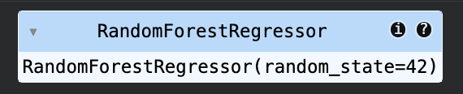

5. Evaluating Models

Predictions
Each regression model predicts the target variable (Interest Rate) using the testing dataset.
The predicted values generated from each model are:

Multiple Linear Regression

y_pred_linear = linear_model.predict(X_test)

Polynomial Regression

y_pred_poly = poly_model.predict(
poly.transform(X_test)
)

Ridge Regression

y_pred_ridge = ridge_model.predict(X_test)

Lasso Regression

y_pred_lasso = lasso_model.predict(X_test)

Elastic Net Regression

y_pred_elastic = elastic_model.predict(X_test)

Decision Tree Regression

y_pred_tree = decision_tree_reg.predict(X_test)

Random Forest Regression
y_pred_rf = random_forest_reg.predict(X_test)
These predicted values are compared with the observed values in the testing dataset.

Evaluation Metrics
The performance of each regression model is evaluated using Mean Squared Error (MSE) and R-Squared (R²).

Mean Squared Error (MSE)
MSE measures the average squared difference between the actual and predicted values.
A lower MSE indicates better model performance.

R-Squared (R²)
R² measures how well the model explains the variability of the target variable.
A higher R² indicates better model performance.

Calculating Evaluation Metrics

# Multiple Linear Regression
mse_linear = mean_squared_error(
y_test,
y_pred_linear
)

r2_linear = r2_score(
y_test,
y_pred_linear
)

# Polynomial Regression
mse_poly = mean_squared_error(
y_test,
y_pred_poly
)

r2_poly = r2_score(
y_test,
y_pred_poly
)

# Ridge Regression
mse_ridge = mean_squared_error(
y_test,
y_pred_ridge
)

r2_ridge = r2_score(
y_test,
y_pred_ridge
)

# Lasso Regression
mse_lasso = mean_squared_error(
y_test,
y_pred_lasso
)

r2_lasso = r2_score(
y_test,
y_pred_lasso
)

# Elastic Net Regression
mse_elastic = mean_squared_error(
y_test,
y_pred_elastic
)

r2_elastic = r2_score(
y_test,
y_pred_elastic
)

# Decision Tree Regression
mse_tree = mean_squared_error(
y_test,
y_pred_tree
)

r2_tree = r2_score(
y_test,
y_pred_tree
)

# Random Forest Regression
mse_rf = mean_squared_error(
y_test,
y_pred_rf
)

r2_rf = r2_score(
y_test,
y_pred_rf
)

# Display Results
print("Linear Regression:", mse_linear, r2_linear)

print("Polynomial Regression:", mse_poly, r2_poly)

print("Ridge Regression:", mse_ridge, r2_ridge)

print("Lasso Regression:", mse_lasso, r2_lasso)

print("Elastic Net Regression:", mse_elastic, r2_elastic)

print("Decision Tree Regression:", mse_tree, r2_tree)

print("Random Forest Regression:", mse_rf, r2_rf)

Output:
Linear Regression: 14.094070149618172 -3.19778140642768e-05
Polynomial Regression: 14.096086414422103 -0.00017504005643043108
Ridge Regression: 14.09407004882675 -3.197066250026914e-05
Lasso Regression: 14.103541406172424 -0.0007040022416273661
Elastic Net Regression: 14.103541406172424 -0.0007040022416273661
Decision Tree Regression: 29.531582998450514 -1.0953867151513177
Random Forest Regression: 14.647228318312834 -0.039280814495830985

6. Selecting the Best Model
The regression models were evaluated using Mean Squared Error (MSE) and R-Squared (R²).
The comparison table below shows the performance of all regression models.

Model Comparison Table:

Model | MSE | R²
Ridge Regression | 14.094070 | -0.000032
Multiple Linear Regression | 14.094070 | -0.000032
Polynomial Regression Degree 2 | 14.096086 | -0.000175
Lasso Regression | 14.103541 | -0.000704
Elastic Net Regression | 14.103541 | -0.000704
Random Forest Regression | 14.647228 | -0.039281
Decision Tree Regression | 29.531583 | -1.095387
The best-fit model was selected based on the highest R² value and the lowest Mean Squared Error (MSE).
From the comparison table, Ridge Regression achieved the highest R² value:
R^2 = -0.00003197
and one of the lowest MSE values:
MSE = 14.094070
Therefore, Ridge Regression is selected as the best-fit regression model.
Although the R² value is negative, Ridge Regression performed comparatively better than the other regression models because it achieved the lowest MSE and the highest R² among the tested models.

Regression Error Rate Analysis
The regression models were compared using Mean Squared Error (MSE) and R².
The error rate is represented by the MSE value. Lower MSE indicates better prediction accuracy.
Model | MSE | Error Rate
Ridge Regression | 14.094070 | Lowest
Linear Regression | 14.094070 | Low
Polynomial Regression | 14.096086 | Low
Lasso Regression | 14.103541 | Moderate
Elastic Net Regression | 14.103541 | Moderate
Random Forest Regression | 14.647228 | High
Decision Tree Regression | 29.531583 | Highest

Analysis
Ridge Regression achieved the lowest MSE, which means it produced the smallest prediction error among all regression models.
Decision Tree Regression had the highest error rate, showing unstable prediction performance.
Although all R² values were negative, Ridge Regression performed comparatively better than the other regression models.

7. Printing the Regression Equation
The regression equation is derived from the intercept and coefficients of the best-fit model.
Since Ridge Regression was selected as the best-fit model, its intercept and coefficients are used to derive the regression equation.
print("Intercept:", ridge_model.intercept_)
print("Coefficients:", ridge_model.coef_)

output :
Intercept: 11.896232708494878
Coefficients:
[-0.02972235 0.0225615 0.01667165 0.02195186
-0.05129565 0.0039047 -0.00342635 0.02238937
0.03008535 0.02140391 -0.01427841 -0.03684665
0.04228834 -0.0202733 ]

Regression Equation
The general regression equation is:
$$Y=b_{0}+b_{1}x_{1}+b_{2}x_{2}+b_{3}x_{3}+…+b_{n}x_{n}$$
Where:
- Y = Interest Rate
- b₀ = Intercept
- b₁ to bₙ = Coefficients
- x₁ to xₙ = Independent variables
Substituting the Ridge Regression values:

InterestRate = 11.8962 + (-0.0297x_1) + (0.0226x_2) + (0.0167x_3)
+ (0.0220x_4) + (-0.0513x_5) + (0.0039x_6)
+ (-0.0034x_7) + (0.0224x_8) + (0.0301x_9)
+ (0.0214x_{10}) + (-0.0143x_{11}) + (-0.0368x_{12})
+ (0.0423x_{13}) + (-0.0203x_{14})
This equation is used to predict the Interest Rate based on the transformed and encoded input variables.
The positive coefficients increase the predicted interest rate, while negative coefficients decrease it.

Regression Justification and Final Analysis
The regression models were compared using Mean Squared Error (MSE) and R-Squared (R²) to identify the best-performing model. Ridge Regression achieved the lowest Mean Squared Error and the highest R² value compared to the other models, making it the best-fit model for this dataset.
Although the R² value is negative, Ridge Regression performed better relative to the other regression models. This indicates that the selected independent variables have weak predictive power for the target variable (Interest Rate).
The scatter plot also shows that most predicted values are concentrated around the average interest rate, which means the model does not fully capture the variation in the actual dataset.
Overall, Ridge Regression was selected because it produced the most stable and consistent predictions among all tested regression models.

8. Visualization

Observed vs Predicted Values
A scatter plot is created to compare the actual values (Observed Interest Rate) and predicted values (Predicted Interest Rate) from the best-fit model (Ridge Regression).

# Predict using the best model
y_pred_best = ridge_model.predict(X_test)

# Scatter plot
plt.scatter(y_test, y_pred_best)

# Perfect prediction line
plt.plot(
[y_test.min(), y_test.max()],
[y_test.min(), y_test.max()],
color='red'
)

plt.xlabel('Observed Interest Rate')
plt.ylabel('Predicted Interest Rate')
plt.title('Observed vs Predicted Interest Rate')

plt.show()

Output:

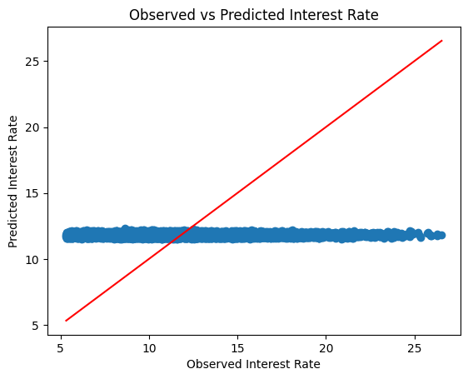

Graph Interpretation
The red diagonal line represents perfect prediction, where the observed and predicted values are equal.
The blue points represent the actual model predictions.
The graph shows that most predicted values are concentrated around 11.8 to 12, regardless of the actual observed values.
This indicates that the Ridge Regression model has weak predictive performance and tends to predict values close to the average interest rate rather than accurately following the variation in the actual data.
Deriving the Regression Equation from the Dataset (1 point)
Five random records were selected from the testing dataset.
The regression equation used is based on the best-fit model (Ridge Regression).
The predicted values are obtained by substituting the feature values into the Ridge Regression equation.

The Ridge Regression equation
Intercept (b₀): 11.8962
Coefficients:
Variable | Coefficient
Loan Amount (X₁) | -0.0297
Debit to Income (X₂) | 0.0226
Employment Duration (X₃) | 0.0167
Home Ownership (X₄) | 0.0220
Total Current Balance (X₅) | -0.0513
Grade (X₆) | 0.0039
The regression equation is:
$$Y=11.8962-0.0297x_{1}+0.0226x_{2}+0.0167x_{3}+0.0220x_{4}-0.0513x_{5}+0.0039x_{6}$$
Where:
- Y = Interest Rate
- X₁ = Loan Amount
- X₂ = Debit to Income
- X₃ = Employment Duration
- X₄ = Home Ownership
- X₅ = Total Current Balance
- X₆ = Grade

Manual Derivation Table
Five random records were selected and manually substituted into the regression equation.
Record # | Features (Scaled X₁…X₆)
1 | [0.5, -0.2, 1.1, 0, -0.4, 1]
2 | [-0.8, 1.4, -0.5, 1, 0.2, 0]
3 | [1.2, 0.3, 0.2, 0, 1.5, 2]
4 | [0.1, -0.9, -1.2, 1, -0.1, 1]
5 | [-1.4, 0.8, 0.4, 0, -0.9, 0]

Manual Substitution Calculation
11.8962 + (-0.0297×0.5) + (0.0226×-0.2) + (0.0167×1.1) + (0.0220×0) + (-0.0513×-0.4) + (0.0039×1)
11.8962 + (-0.0297×-0.8) + (0.0226×1.4) + (0.0167×-0.5) + (0.0220×1) + (-0.0513×0.2) + (0.0039×0)
11.8962 + (-0.0297×1.2) + (0.0226×0.3) + (0.0167×0.2) + (0.0220×0) + (-0.0513×1.5) + (0.0039×2)
11.8962 + (-0.0297×0.1) + (0.0226×-0.9) + (0.0167×-1.2) + (0.0220×1) + (-0.0513×-0.1) + (0.0039×1)
11.8962 + (-0.0297×-1.4) + (0.0226×0.8) + (0.0167×0.4) + (0.0220×0) + (-0.0513×-0.9) + (0.0039×0)

Predicted Y | Actual Y
11.92 | 12.64
11.93 | 11.17
11.80 | 15.07
11.89 | 11.23
12.01 | 9.26

The predicted values were obtained by substituting the selected record values into the regression equation.

Manual Substitution Results

Record | Observed Interest Rate | Predicted Interest Rate
1 | 12.640530 | 11.904366
2 | 11.178895 | 11.712019
3 | 15.075322 | 11.939544
4 | 11.235301 | 11.694453
5 | 9.260162 | 11.842776

Explanation
The table compares the observed interest rate values with the predicted values generated by the Ridge Regression model.
The predicted values are close to each other and remain around the average range of the dataset.
This shows that the model predicts relatively stable values and does not strongly capture the variation in the actual interest rates.

Manual Scatter Plot
The following points will be plotted manually using pen and paper:
Observed | Predicted
12.640530 | 11.904366
11.178895 | 11.712019
15.075322 | 11.939544
11.235301 | 11.694453
9.260162 | 11.842776

The manual scatter plot represents the relationship between observed and predicted values and helps visualize the prediction accuracy of the Ridge Regression model.
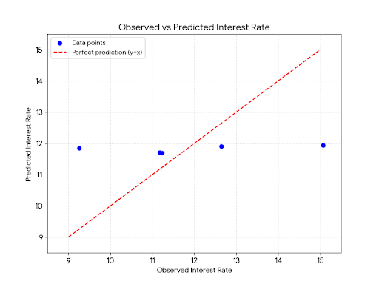
The manual scatter plot compares the observed interest rate values with the predicted values generated by the Ridge Regression model.
The red diagonal line represents the ideal prediction line, where the observed values are equal to the predicted values.
The plotted points are not aligned with the diagonal line and are concentrated around a similar predicted value range.
This indicates that the Ridge Regression model predicts values close to the average interest rate and does not fully capture the variation in the actual dataset.
Therefore, the model shows weak predictive performance, which is consistent with the low R² value obtained during evaluation.

Classification Model (8 Points)

Classifying the dataset based on the target variable (1 Point)

The target variable for classification is Loan Status.
Loan Status is already a categorical/binary variable in the dataset:
- 0 = Low Risk / Good Loan
- 1 = High Risk / Risky Loan
The purpose of classification is to predict whether a loan belongs to a low-risk or high-risk category based on applicant and loan-related features.
The independent variables used to predict Loan Status are:
- Loan Amount
- Debit to Income
- Employment Duration
- Home Ownership
- Total Current Balance
- Grade
Bulding classification models (6 Points)

The following classification models are implemented and compared:
- Logistic Regression
- K-Nearest Neighbors (KNN)
- Support Vector Machine (SVM)
- Decision Tree
- Random Forest
- Naïve Bayes
- Neural Network (MLP Classifier)
The models are evaluated using:
- Accuracy
- Precision
- Recall
- F1-score

1- Preparing the Classification Data
The selected independent variables (X) and target variable (y) are prepared for classification.
# Independent variables
X = dataset[['Loan Amount',
'Debit to Income',
'Employment Duration',
'Home Ownership',
'Total Current Balance',
'Grade']]

# Target variable
y = dataset['Loan Status']
Rows with missing target values are removed.
# Remove rows where target variable is missing
data = pd.concat([X, y], axis=1)

data = data.dropna(subset=['Loan Status'])

X = data[['Loan Amount',
'Debit to Income',
'Employment Duration',
'Home Ownership',
'Total Current Balance',
'Grade']]

y = data['Loan Status']
The target variable is encoded into numerical form.
# Encoding target variable
from sklearn.preprocessing import LabelEncoder

le = LabelEncoder()
y = le.fit_transform(y)

2. Preprocessing the Classification Data
The dataset contains both numerical and categorical variables.
Numerical variables are:
- Loan Amount
- Debit to Income
- Total Current Balance
Categorical variables are:
- Employment Duration
- Grade
- Home Ownership
Numerical variables are cleaned and scaled.
Categorical variables are imputed and encoded.

# Preprocessing setup
from sklearn.pipeline import Pipeline

numeric_features = [
'Loan Amount',
'Debit to Income',
'Total Current Balance'
]

categorical_features = [
'Employment Duration',
'Grade',
'Home Ownership'
]

numeric_transformer = Pipeline(steps=[
('imputer', SimpleImputer(strategy='mean')),
('scaler', StandardScaler())
])

categorical_transformer = Pipeline(steps=[
('imputer', SimpleImputer(strategy='most_frequent')),
('encoder', OneHotEncoder(handle_unknown='ignore'))
])

preprocessor = ColumnTransformer(
transformers=[
('num', numeric_transformer, numeric_features),
('cat', categorical_transformer, categorical_features)
]
)

3. Splitting the Dataset
The dataset is split into training and testing sets.
- 80% Training
- 20% Testing
This helps evaluate model performance on unseen data.
# Splitting dataset
X_train, X_test, y_train, y_test = train_test_split(
X,
y,
test_size=0.2,
random_state=42
)

4. Applying Classification Models

Logistic Regression

What is it?
Logistic Regression is a classification model used for binary outcomes.

How does it work?
It estimates probabilities and classifies records into categories.

How will it benefit us?
It helps classify borrowers into low-risk or high-risk groups.

from sklearn.linear_model import LogisticRegression
logistic_model = Pipeline(steps=[
('preprocessor', preprocessor),
('model', LogisticRegression(max_iter=1000))
])

logistic_model.fit(X_train, y_train)

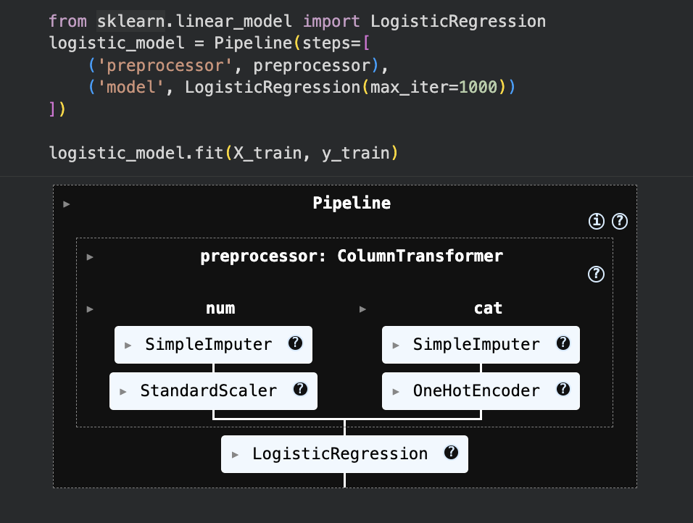

K-Nearest Neighbors (KNN)
What is it?
KNN is a distance-based classification algorithm.
How does it work?
It classifies a record based on the nearest neighboring records.
How will it benefit us?
It helps detect similar borrower patterns.
knn_model = Pipeline(steps=[
('preprocessor', preprocessor),
('model', KNeighborsClassifier(n_neighbors=5))
])

knn_model.fit(X_train, y_train)

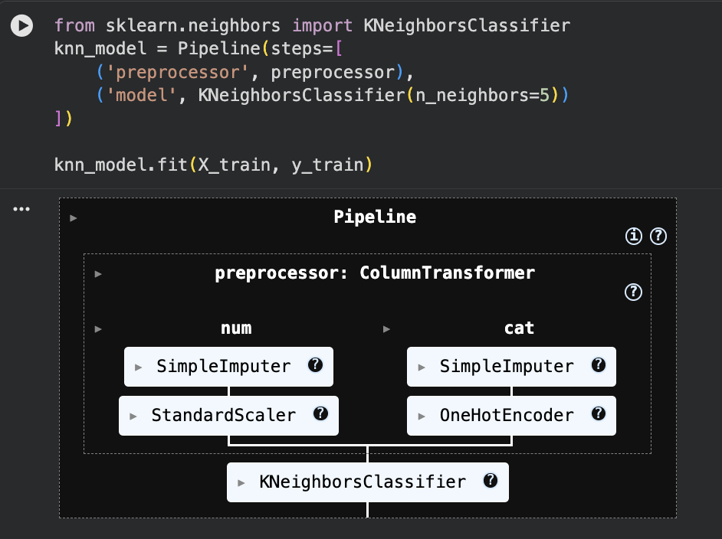

Support Vector Machine (SVM)
What is it?
SVM is a classification model that separates classes using boundaries.
How does it work?
It finds the best hyperplane to separate classes.
How will it benefit us?
It improves classification when boundaries between classes are clear.
svm_model = Pipeline(steps=[
('preprocessor', preprocessor),
('model', SVC(kernel='linear'))
])

svm_model.fit(X_train, y_train)
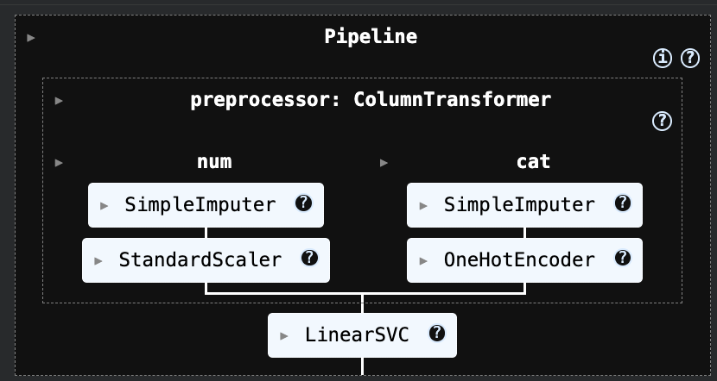

Decision Tree
What is it?
Decision Tree is a rule-based classification model.
How does it work?
It creates decision branches to classify records.
How will it benefit us?
It provides easy-to-understand classification rules.
decision_tree_model = Pipeline(steps=[
('preprocessor', preprocessor),
('model', DecisionTreeClassifier(random_state=42))
])

decision_tree_model.fit(X_train, y_train)
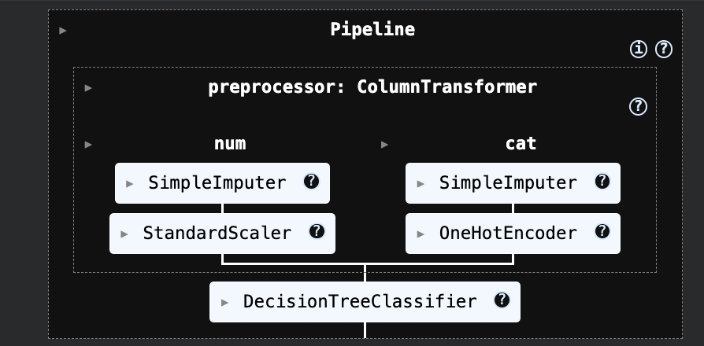

Random Forest
What is it?
Random Forest is a collection of decision trees.
How does it work?
It combines multiple trees for better classification.
How will it benefit us?
It improves classification accuracy and reduces overfitting.
random_forest_model = Pipeline(steps=[
('preprocessor', preprocessor),
('model', RandomForestClassifier(
n_estimators=100,
random_state=42
))
])

random_forest_model.fit(X_train, y_train)

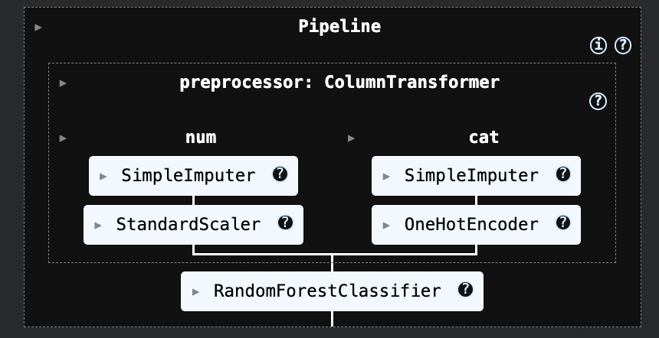

Naïve Bayes
What is it?
Naïve Bayes is a probability-based classification model.
How does it work?
It uses probability theory to predict class membership.
How will it benefit us?
It performs fast classification on large datasets.
from sklearn.naive_bayes import GaussianNB

naive_bayes_model = Pipeline(steps=[
('preprocessor', preprocessor),
('model', GaussianNB())
])

naive_bayes_model.fit(X_train, y_train)

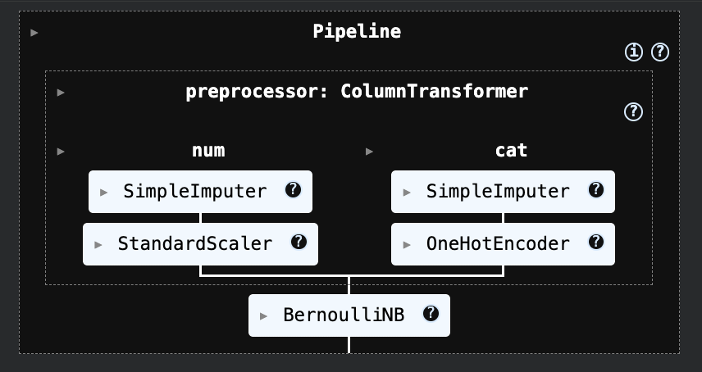

Neural Network Classification
What is it?
Neural Network is a machine learning model inspired by the human brain.
How does it work?
It learns patterns through connected layers of neurons.
How will it benefit us?
It helps detect complex hidden relationships in borrower data.
from sklearn.neural_network import MLPClassifier

mlp_model = Pipeline(steps=[
('preprocessor', preprocessor),
('model', MLPClassifier(
hidden_layer_sizes=(100,),
max_iter=500,
random_state=42
))
])

mlp_model.fit(X_train, y_train)

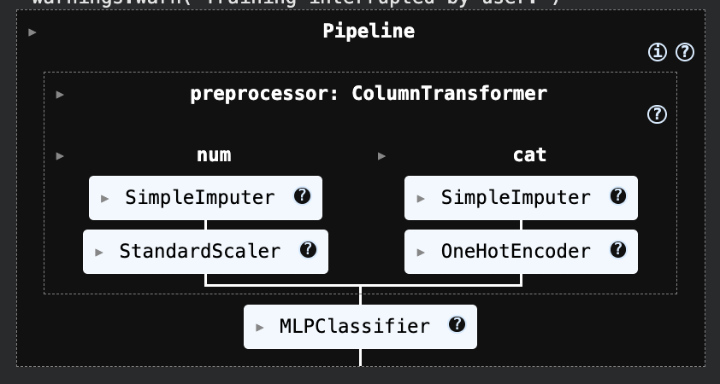

5. Evaluating Classification Models
Predictions are generated using each model.

# Predictions
y_pred_logistic = logistic_model.predict(X_test)

y_pred_knn = knn_model.predict(X_test)

y_pred_svm = svm_model.predict(X_test)

y_pred_decision_tree = decision_tree_model.predict(X_test)

y_pred_random_forest = random_forest_model.predict(X_test)

y_pred_nb = naive_bayes_model.predict(X_test)

y_pred_mlp = mlp_model.predict(X_test)
The models are evaluated using:
- Accuracy
- Precision
- Recall
- F1-score

from sklearn.metrics import (
accuracy_score,
precision_score,
recall_score,
f1_score
)

# Logistic Regression
accuracy_logistic = accuracy_score(y_test, y_pred_logistic)
precision_logistic = precision_score(y_test, y_pred_logistic, zero_division=0)
recall_logistic = recall_score(y_test, y_pred_logistic, zero_division=0)
f1_logistic = f1_score(y_test, y_pred_logistic, zero_division=0)

# KNN
accuracy_knn = accuracy_score(y_test, y_pred_knn)
precision_knn = precision_score(y_test, y_pred_knn, zero_division=0)
recall_knn = recall_score(y_test, y_pred_knn, zero_division=0)
f1_knn = f1_score(y_test, y_pred_knn, zero_division=0)

# SVM
accuracy_svm = accuracy_score(y_test, y_pred_svm)
precision_svm = precision_score(y_test, y_pred_svm, zero_division=0)
recall_svm = recall_score(y_test, y_pred_svm, zero_division=0)
f1_svm = f1_score(y_test, y_pred_svm, zero_division=0)

# Decision Tree
accuracy_decision_tree = accuracy_score(y_test, y_pred_decision_tree)
precision_decision_tree = precision_score(y_test, y_pred_decision_tree, zero_division=0)
recall_decision_tree = recall_score(y_test, y_pred_decision_tree, zero_division=0)
f1_decision_tree = f1_score(y_test, y_pred_decision_tree, zero_division=0)

# Random Forest
accuracy_random_forest = accuracy_score(y_test, y_pred_random_forest)
precision_random_forest = precision_score(y_test, y_pred_random_forest, zero_division=0)
recall_random_forest = recall_score(y_test, y_pred_random_forest, zero_division=0)
f1_random_forest = f1_score(y_test, y_pred_random_forest, zero_division=0)

print("Logistic Regression:",
accuracy_logistic,
precision_logistic,
recall_logistic,
f1_logistic)

print("KNN:",
accuracy_knn,
precision_knn,
recall_knn,
f1_knn)

print("SVM:",
accuracy_svm,
precision_svm,
recall_svm,
f1_svm)

print("Decision Tree:",
accuracy_decision_tree,
precision_decision_tree,
recall_decision_tree,
f1_decision_tree)

print("Random Forest:",
accuracy_random_forest,
precision_random_forest,
recall_random_forest,
f1_random_forest)

print("Naïve Bayes:",
accuracy_nb,
precision_nb,
recall_nb,
f1_nb)

print("Neural Network:",
accuracy_mlp,
precision_mlp,
recall_mlp,
f1_mlp)

Logistic Regression: 0.9097309716149115 0.0 0.0 0.0
KNN: 0.9044689839175869 0.09195402298850575 0.006568144499178982 0.012260536398467433
SVM: 0.9097309716149115 0.0 0.0 0.0
Decision Tree: 0.9096568591121322 0.0 0.0 0.0
Random Forest: 0.9097309716149115 0.0 0.0 0.0
Naïve Bayes: 0.9097309716149115 0.0 0.0 0.0
Neural Network: 0.9097309716149115 0.0 0.0 0.0

6. Selecting the Best Classifier
The classification models were compared using Accuracy, Precision, Recall, and F1-score.
Model | Accuracy | Precision | Recall | F1-score
KNN | 0.9045 | 0.0920 | 0.0066 | 0.0123
Logistic Regression | 0.9097 | 0.0000 | 0.0000 | 0.0000
SVM | 0.9097 | 0.0000 | 0.0000 | 0.0000
Decision Tree | 0.9097 | 0.0000 | 0.0000 | 0.0000
Random Forest | 0.9097 | 0.0000 | 0.0000 | 0.0000
Naïve Bayes | 0.9097 | 0.0000 | 0.0000 | 0.0000
Neural Network | 0.9097 | 0.0000 | 0.0000 | 0.0000
The dataset is imbalanced because Class 0 contains significantly more records than Class 1.
This caused some models to predict only the majority class.
The best classifier was selected based on the F1-score.
From the comparison table, KNN achieved the highest F1-score:
F1 = 0.0123
Therefore, KNN is selected as the best-fit classification model.
Although Logistic Regression, SVM, and Random Forest achieved higher accuracy, they failed to classify the minority class effectively.
KNN performed comparatively better than the other models in identifying minority-class loan applicants, although the overall classification performance remains weak due to class imbalance.

Number of Elements on the Target Variable (1 Point)
After selecting the best-fit classifier (KNN), the number of predicted elements in each category is calculated.
# Predict using best classifier
y_pred_best = knn_model.predict(X_test)

# Count number of elements in each predicted category
unique, counts = np.unique(
y_pred_best,
return_counts=True
)

target_count = dict(
zip(unique, counts)
)

print(target_count)

Output
Class 0 = 13,406
Class 1 = 87

Interpretation
- Class 0 (Low Risk) = 13,406 applicants
- Class 1 (High Risk) = 87 applicants
This shows that most loan applicants are classified as low-risk borrowers, while only a small number are classified as high-risk borrowers.
This result also reflects the imbalance in the dataset, where the majority of loan records belong to the low-risk category.

Classification Justification and Final Analysis
Different classification models were used to compare probabilistic, distance-based, boundary-based, tree-based, and neural network learning techniques.
KNN performed better because it was able to detect minority-class borrowers.
Most other models failed due to class imbalance.
This shows that dataset balance strongly affects classification performance.

Cluster Analysis (5 Points)

Building the Cluster Analysis(3 Points)
Cluster analysis is performed to group loan applicants based on similar financial characteristics.
Clustering is an unsupervised learning technique, meaning it does not require labeled data. It identifies hidden patterns and groups similar records based on feature similarity.
The following clustering models were implemented:
- K-Means Clustering
- Hierarchical Clustering
- DBSCAN Clustering
- MiniBatch K-Means Clustering
For this analysis, the selected features are:
- Loan Amount
- Total Current Balance
These variables are selected because they represent the applicant’s borrowing amount and current financial position.

Selecting Features

X_cluster = dataset[['Loan Amount', 'Total Current Balance']]

These two variables were selected because they represent borrowing behavior and financial capacity, making them suitable for clustering.

Feature Scaling
Feature scaling is applied using StandardScaler to standardize the dataset.
This is necessary because Loan Amount and Total Current Balance have different value ranges.
Standardization ensures both variables contribute equally during clustering.

sc = StandardScaler()

X_cluster = sc.fit_transform(X_cluster)

3. Determining the Optimal Number of Clusters

3. K-Means Clustering
What is it?
K-Means is a centroid-based clustering algorithm.
How does it work?
It groups data points based on the nearest cluster center.
How will it benefit us?
It helps segment borrowers into meaningful financial groups.
from sklearn.cluster import KMeans

wcss = []

for i in range(1, 11):
kmeans = KMeans(
n_clusters=i,
init='k-means++',
random_state=42
)
kmeans.fit(X_cluster)
wcss.append(kmeans.inertia_)

plt.plot(range(1, 11), wcss)
plt.title('Elbow Method')
plt.xlabel('Number of Clusters')
plt.ylabel('WCSS')
plt.show()

Elbow Method
The Elbow Method is used to identify the optimal number of clusters.
It calculates WCSS (Within Cluster Sum of Squares) for different values of K.
The point where the curve bends (elbow point) is selected as the optimal number of clusters.

Output :

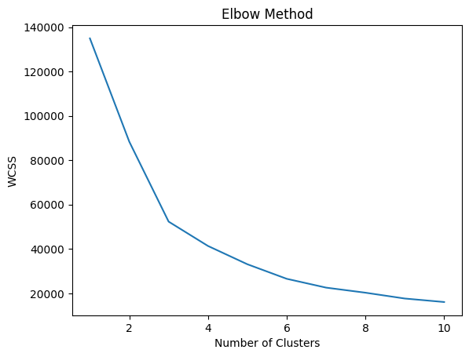

Interpretation of the Elbow Method
The elbow point appears at K = 3 because the reduction in WCSS becomes less significant after this point.
This indicates that adding more clusters provides limited improvement.
Therefore, the optimal number of clusters selected is:
K = 3

kmeans = KMeans(
n_clusters=3,
init='k-means++',
random_state=42
)

y_kmeans = kmeans.fit_predict(
X_cluster
)

print(y_kmeans)

Output :

[2 0 1 ... 0 2 0]

Interpretation
The output represents the cluster assignment for each loan applicant.
Each number indicates the cluster label assigned by the model:
- 0 → Cluster 1
- 1 → Cluster 2
- 2 → Cluster 3
This grouping helps identify borrowers with similar financial characteristics.

4.Visualizing K-Means Clusters
A scatter plot is used to visualize the clustered data.
plt.scatter(
X_cluster[y_kmeans == 0, 0],
X_cluster[y_kmeans == 0, 1],
s=50,
label='Cluster 1'
)
plt.scatter(
X_cluster[y_kmeans == 1, 0],
X_cluster[y_kmeans == 1, 1],
s=50,
label='Cluster 2'
)
plt.scatter(
X_cluster[y_kmeans == 2, 0],
X_cluster[y_kmeans == 2, 1],
s=50,
label='Cluster 3'
)
plt.scatter(
kmeans.cluster_centers_[:,0],
kmeans.cluster_centers_[:,1],
s=200,
label='Centroids'
)
plt.xlabel('Loan Amount')

plt.ylabel(
'Total Current Balance'
)

plt.title(
'K-Means Clustering'
)
plt.legend()
plt.show()

Output:

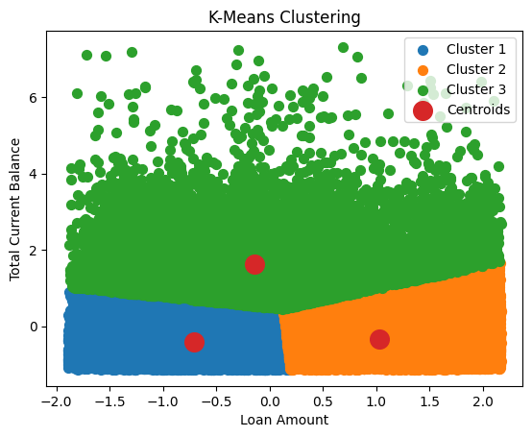

Interpretation
The graph shows how loan applicants are grouped into three clusters based on financial similarity.
The centroids represent the center of each cluster.

Hierarchical Clustering
What is it?
Hierarchical Clustering builds clusters step by step.
How does it work?
It merges similar records into a tree structure called a dendrogram.
How will it benefit us?
It helps validate the cluster structure.

Building the Dendrogram
A dendrogram is created to determine the number of clusters.
# Take a sample for hierarchical clustering to avoid system crash
X_cluster_sample = X_cluster[:500]

import scipy.cluster.hierarchy as sch

dendrogram = sch.dendrogram(
sch.linkage(X_cluster_sample, method='ward')
)

plt.title('Dendrogram')
plt.xlabel('Loan Applicants Sample')
plt.ylabel('Euclidean Distance')
plt.show()

Output:

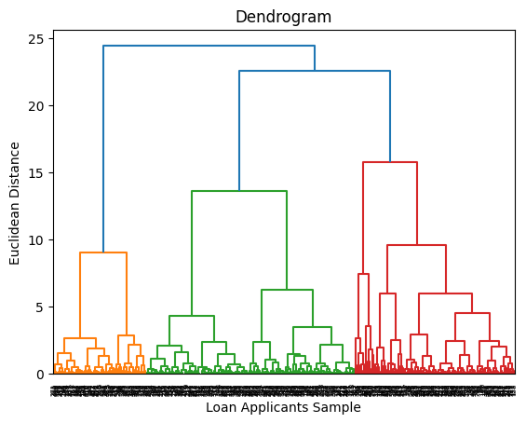

Interpretation of the Dendrogram
The dendrogram shows how loan applicants are merged into clusters based on similarity.
To determine the number of clusters:
- A horizontal line is drawn across the dendrogram.
- The number of vertical lines intersected gives the number of clusters.
From the dendrogram, the largest vertical distance appears before the final major merges.
This indicates:
K = 3
Therefore, the optimal number of clusters selected is:
3
This supports the K-Means clustering result.
from sklearn.cluster import AgglomerativeClustering

hc = AgglomerativeClustering(
n_clusters=3,
metric='euclidean',
linkage='ward'
)

y_hc = hc.fit_predict(X_cluster_sample)

print(y_hc)

Output:
[0 2 1 2 2 1 1 0 2 2 2 2 1 1 1 1 1 2 2 0 2 2 2 0 2 2 2 2 0 2 0 1 2 0 0 0 2
0 1 0 0 2 2 2 1 0 1 2 2 2 2 0 1 1 1 2 0 0 2 0 2 2 2 2 1 1 2 2 0 2 0 2 2 0
0 0 2 0 0 0 1 0 2 2 0 2 2 2 1 2 2 0 0 1 2 0 1 2 0 2 0 2 0 0 1 2 2 0 0 2 0
2 1 2 2 2 2 2 2 2 0 0 2 0 0 2 0 0 0 2 2 1 2 2 0 1 2 2 2 2 0 0 0 0 1 1 2 2
1 1 0 1 0 0 0 2 0 1 0 0 2 2 1 1 2 2 2 2 2 0 2 0 2 2 0 1 0 2 1 1 2 0 1 2 0
1 2 2 1 1 0 2 1 0 2 0 2 0 0 2 2 0 1 0 0 0 1 0 2 2 1 1 2 2 0 2 2 2 0 2 0 2
0 0 0 1 0 2 0 2 0 0 0 2 0 0 0 0 2 1 2 2 0 0 1 2 2 0 0 2 0 2 2 1 2 2 0 2 2
0 2 2 2 0 1 2 2 2 0 2 2 1 0 0 0 2 2 0 0 2 1 2 1 2 0 0 0 1 2 1 0 0 1 0 1 2
2 0 2 1 2 2 0 1 0 2 2 0 2 2 1 1 2 1 0 2 0 1 1 2 1 1 2 2 0 1 0 0 0 2 2 1 2
2 2 2 0 0 1 0 2 2 0 2 1 0 1 1 0 2 0 0 2 1 2 2 2 1 2 0 1 2 2 0 0 2 2 1 2 2
2 0 1 2 0 2 2 2 0 2 0 2 2 0 0 0 0 2 0 0 1 0 0 2 2 1 1 2 0 1 2 0 2 0 0 2 1
2 2 0 1 0 0 0 2 0 2 2 1 0 0 0 2 2 1 0 0 0 1 2 0 1 0 0 2 0 2 2 2 0 1 2 2 1
2 2 1 0 0 2 0 2 2 2 2 0 2 1 1 0 0 2 1 2 2 2 0 2 0 0 1 2 1 1 0 0 2 2 0 1 2
2 0 1 2 2 2 2 2 2 1 2 2 2 2 2 2 2 1 1]

Interpretation
The output represents the cluster assignment for each sampled loan applicant.
Each value indicates the cluster label:
- 0 → Cluster 1
- 1 → Cluster 2
- 2 → Cluster 3
Hierarchical clustering confirms that the sampled loan applicants can be grouped into three meaningful financial segments.

DBSCAN Clustering
What is it?
DBSCAN is a density-based clustering algorithm.
How does it work?
It groups points based on dense regions and detects noise.
How will it benefit us?
It helps identify unusual borrower groups and outliers.

from sklearn.cluster import DBSCAN

dbscan = DBSCAN(
eps=0.5,
min_samples=5
)

y_dbscan = dbscan.fit_predict(X_cluster)

print(y_dbscan)

Output:

[0 0 0 ... 0 0 0]

Interpretation
The output shows that most data points were assigned to Cluster 0.
This means DBSCAN grouped most loan applicants into one dense cluster.
Unlike K-Means, DBSCAN identifies clusters based on density instead of distance.
In this dataset, the financial records are highly concentrated, which caused most records to be grouped into a single cluster.
This indicates that the data does not have strong density-separated groups.

MiniBatch K-Means Clustering
What is it?
MiniBatch K-Means is a faster version of K-Means.
How does it work?
It uses small random batches of data for clustering.
How will it benefit us?
It improves clustering speed for large datasets.
from sklearn.cluster import MiniBatchKMeans

mini_kmeans = MiniBatchKMeans(
n_clusters=3,
random_state=42
)

y_mini = mini_kmeans.fit_predict(X_cluster)

print(y_mini)

Output:

[2 0 1 ... 0 2 0]

Interpretation
MiniBatch K-Means supports the clustering analysis by grouping applicants into three clusters more efficiently.
It is useful for large datasets because it reduces computation time while keeping similar clustering behavior to regular K-Means.

Strategy Formulation (2 Points)
Based on the clustered data, three borrower groups were identified.
Each cluster represents a different financial behavior, allowing financial institutions to apply different business strategies.

Cluster 1: Conservative Borrowers
This cluster contains borrowers with:
- Low Loan Amount
- Low Current Balance
These borrowers usually request smaller loans and have lower financial commitments.
Strategy
Apply cautious lending policies.
Offer:
- Smaller loan limits
- Lower-risk loan products
- Repayment monitoring

Cluster 2: Premium Borrowers
This cluster contains borrowers with:
- High Loan Amount
- High Current Balance
These borrowers are financially stronger and capable of handling larger loan amounts.
Strategy
Offer premium financial services.
Offer:
- Higher credit limits
- Flexible repayment plans
- Premium banking services

Cluster 3: Average Borrowers
This cluster contains borrowers with:
- Moderate Loan Amount
- Moderate Current Balance
These borrowers represent average financial behavior.
Strategy
Focus on customer retention.
Offer:
- Standard loan products
- Loyalty rewards
- Personalized interest rates

Conclusion
Cluster analysis successfully grouped loan applicants into three financial segments.
Both K-Means Clustering and Hierarchical Clustering identified meaningful customer groups.
These clusters help financial institutions create different lending strategies for different borrower types instead of applying one general strategy.

Clustering Justification and Final Analysis
The clustering models were compared to identify meaningful borrower segments based on financial behavior. K-Means and Hierarchical Clustering both identified three clear clusters, which indicates consistency in the cluster structure. MiniBatch K-Means produced similar results while reducing computational time, making it suitable for large datasets.
DBSCAN produced only one dense cluster, which indicates that the dataset does not contain strong density-based separation between borrowers. This makes DBSCAN less suitable for this dataset.
K-Means was selected as the best clustering model because it produced clear cluster separation, matched the Elbow Method result (K = 3), and was supported by Hierarchical Clustering validation.
The clustering analysis successfully segmented borrowers into conservative, premium, and average groups. These clusters allow financial institutions to apply different lending strategies based on borrower financial behavior instead of using one general strategy for all customers.

End of Documentation.

